**Assignment 17.2**

**DRIVER:**

**IN DRIVER, SET MAPPER CLASS, PARTITIONER CLASS GROUP COMPARATOR CLASS AND COMPOSITE KEY CLASS AS MAP OUTPUT CLASS**

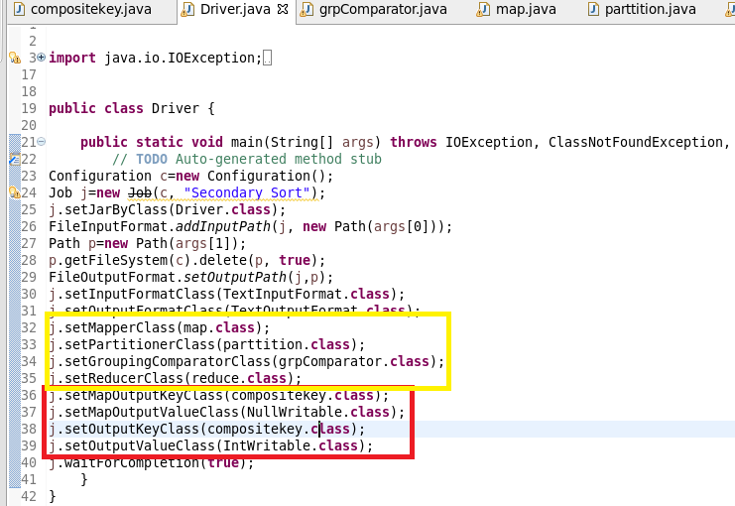

**MAPPER:**

**In mapper class split the data by comma and then send compositekey as key (which consists of combination of year and temperature) and value as null writable**

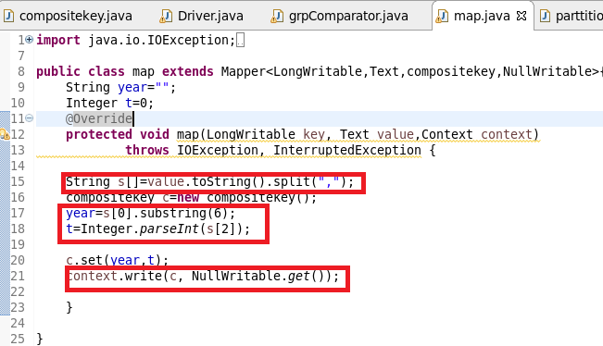

**Composite key class**

**Step1:** Override compare method

Check if year are same if it is same sort the temperature by descending

**Step2:** Override Tostring: to display the way the composite key should be displayed

**Step3:** read fields and write fields is for serialization and deserialization

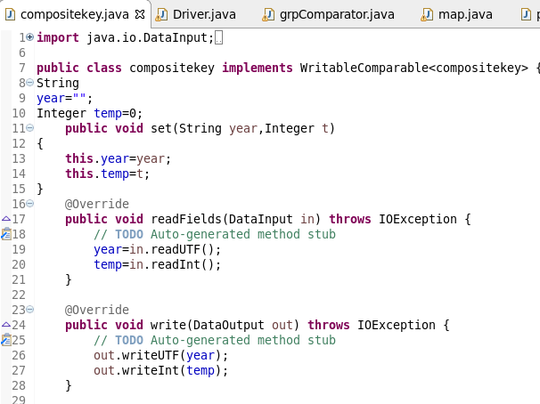

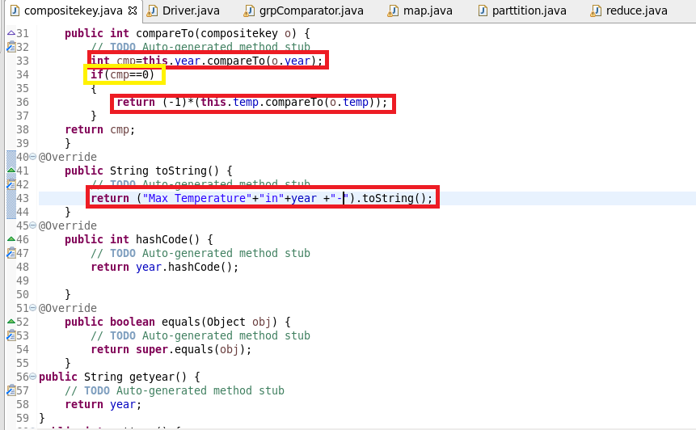

**Custom Partitioner class:**

In partitioner class send the key, value pair from mapper to reducer depending upon hashcode of year

Say all 1990 year data should go to same reducer.

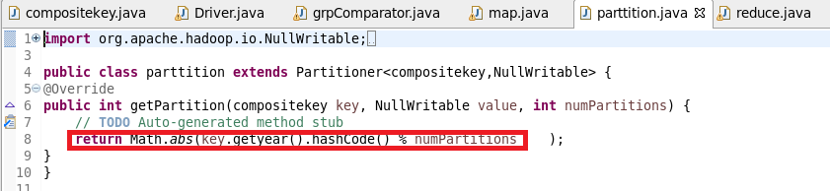

**Group comparator class**

In group comparator class we must say the reducer to group the key based on year

Say if there are 2 keys (1990-12, 1990-23).If we did not override these two keys will be considered as unique so we override compare method and compare by year and the kay will be grouped as follows

1990(1990-23, 1990-12)

1991(1991-12, 1991-15) and so on

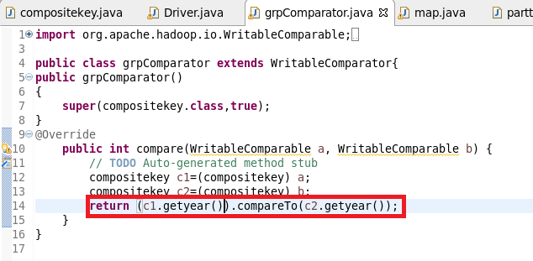

**Reducer:**

In reducer since we want maximum 2 temperature ,I have used linked hashmap of size(2) since we want max 2 temp and Iterate the value and get only top 2 max values as linkedhashmap preserves order and eliminates duplicity as shown

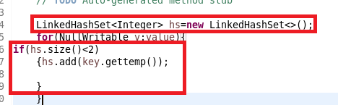

**Then by using Iterator of hashset written these key and values**

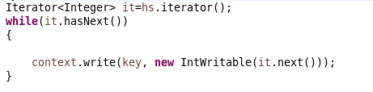

**Complete reducer:**

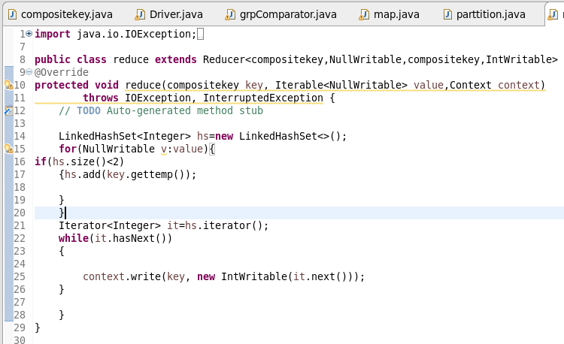

**Running jar:**

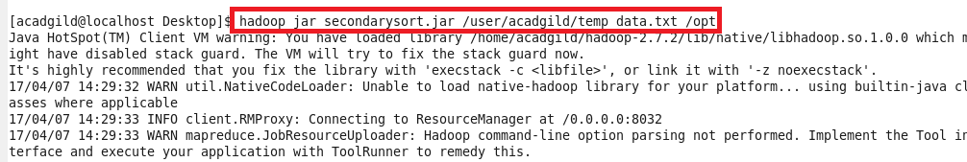

**OUTPUT:**

